CBOE Use-Case Report
<usecase.Name>

Brief Description
<usecase.Documentation>
A trade bust is carried out by the Help Desk and is used to undo a trade. Two types of busts are allowed. A Negotiated Trade Bust is used when some or all parties involved in the trade agree to the bust. A Mandated Trade Bust is used when a trade is executed with an obvious price error.

Flow of Events

Basic Flow

Negotiated Trade Bust
- One participant in the trade requests that the trade be busted by notifying the Help Desk either by phone or by text message.
- The Help Desk activates the Trade Bust function.
- The Help Desk enters the Trade ID to be busted. And, in the case of equities, the date of the trade will be entered as well. Even though the trade ID is unique, even across days, a visual trade date cue would be warranted on a bust. The system will compare the trade’s settlement date against the current date and if the settlement date is in the past, the bust will not be processed. Note: Settlement dates are specific to equities. They typically range T+3 (trade date plus three days, but can be shorter, or even longer).
- Note that if an order is involved in multiple trades, each trade would need to be busted independently in order to bust the entire order.
- The system displays a panel showing all contras involved in the trade. For each contra, the panel will display the order or quote ID, the volume traded, and the trade leg ID.
- The Help Desk sends a text message to all other trade participants requesting the bust.
- Each participant must respond by text message within a time limit of n(30) minutes, either agreeing to the bust or not agreeing to the bust. Any participant who did not respond to the request within the allotted time limit will be treated as if they did not agree to the bust. Volume will default to zero for those participants who did not agree to the bust. If a participant agrees to the bust, the participant must specify the volume to be busted and whether the order should be reinstated. Note that quotes cannot be reinstated.
- After all replies have been received by the Help Desk, or the time limit has elapsed, the Help Desk enters all quantities to be busted. If the order is to be reinstated, the Help Desk will select the Reinstate option. Market, Spread, and Contingency orders cannot be reinstated.
- For each order, the system will increase the busted and remaining volumes and decrease the filled volume by the appropriate amounts.
- For orders that need to be reinstated, the system reinstates orders into the book with the requested volume in the original sequence.
- For equities, the system notifies SIAC CT of the bust or trade correction if this is only a partial bust where simply the volume is changed. For all other products, the system notifies trade match and OPRA of the bust and, if applicable, the reinstatement.
- The system adds the bust to the bust audit trail. For orders, a history item will also be entered with the updated volumes.
- The system sends a bust report containing the trade ID and order or quote ID to the participants affected by the bust.

Mandated Trade Bust
- The Help Desk determines that a trade is eligible for a Mandated Bust. (See Section 6: Preconditions for eligibility criteria.)
- The Help Desk activates the Trade Bust function.
- The Help Desk enters the Trade ID to be busted. Note: Equities trades from previous days will not be allowed to participate in a Mandated Trade Bust.
- The system displays a panel showing all contras involved in the trade. For each contra, the panel will display the order or quote ID, the volume traded, and the trade leg ID.
- The Help Desk sends a text message to all trade participants to notify of the impending bust and ask if the order is to be reinstated. If no response is received from any participant, the order will not be reinstated for that participant.
- The Help Desk enters all quantities to be busted. If the order is to be reinstated, the Help Desk will select the Reinstate option. Market, Contingency, and Spread orders cannot be reinstated.
- For each order, the system will increase the busted and remaining volumes and decrease the filled volume by the appropriate amounts.
- For orders that need to be reinstated, the system reinstates orders into the book with the requested volume in the original sequence.
- For equities, the system notifies SIAC CT of the bust or trade correction if only a partial bust. For all other products, the system notifies trade match and OPRA of the bust and, if applicable, the reinstatement.
- The system adds the bust to the bust audit trail. For orders, a history item will also be entered with the updated volumes.
- The system sends a bust report containing the trade ID and order or quote ID to the participants affected by the bust.

Alternative Flows

Relationships

Actors:
<communicates.OtherRole.FromClass.Name>

Uses and extends associations with:
<usesextends.Stereotype> <usesextends.ToUseCase.Name>

Use-Case Diagrams

<localviews.Name>


Special Requirements

Performance

Security

Preconditions

For a mandated trade bust to be processed by the Help Desk notification must be made to the Help Desk within n(2) minutes of execution and both of the following conditions must be met:
- At the time of the execution, a market at or within the exchange prescribed width was not present.
- The price of the executed trade is greater than the reasonable price level of the series plus (in case of a buy) or minus (in case of a sell) the variation amount.
The percentage will be increased proportionally to the widening of the exchange prescribed quote width for the class during unusual market activity.

Calculation and Notification of Bad Price
Under the Mandated Trade Bust section the Help Desk will calculate the correct price, once notification is given that a bad execution price has occurred.
Notification to both parties will be made of the busting of the trade. The order will be reinstated, in time priority sequence.
In order to verify pricing, the Help Desk will need real time access to trading data.

Determine reasonable price level
The reasonable price level will be considered by the Help Desk to be the lowest bid (on sells) or the highest ask (on buys) of the executed series during the n(10) minutes immediately preceding the placement of the order and the n(5) minute interval beginning n(30) seconds subsequent to the alleged erroneous execution.

Set Variation Amount
The variation amount will be set in normal market activity at:
- 50% of the reasonable price for premiums less than $5
- 40% of the reasonable price for premiums between $5 and $10
- 30% of the reasonable price for premiums over $10

Ability to adjust Variation Amount during unusual market conditions.
As market conditions merit it, it will be necessary for the Help Desk to adjust the variation amount to reflect the change in volatility.
In the event that data is lacking to establish a reasonable price in this manner, a Price Review Panel will determine the theoretical market of the option.
In classes or equities where applicable, the Help Desk will review the markets on Exchanges where products are dually listed in order to determine a reasonable price.
The system will provide the data needed by the Help Desk to determine whether a trade is eligible for the mandatory trade bust.

Postconditions

<< Post-condition One >>

Requirement Traces

Traces From:
<tracesFrom.RelatedReq.TagPrefix><tracesFrom.RelatedReq.TagNumber>: <tracesFrom.RelatedReq.Text> [Suspect: <tracesFrom.Suspect>]

Traces To:
<tracesTo.RelatedReq.TagPrefix><tracesTo.RelatedReq.TagNumber>: <tracesTo.RelatedReq.Text> [Suspect: <tracesTo.Suspect>]

Extended Use Case Decision Table

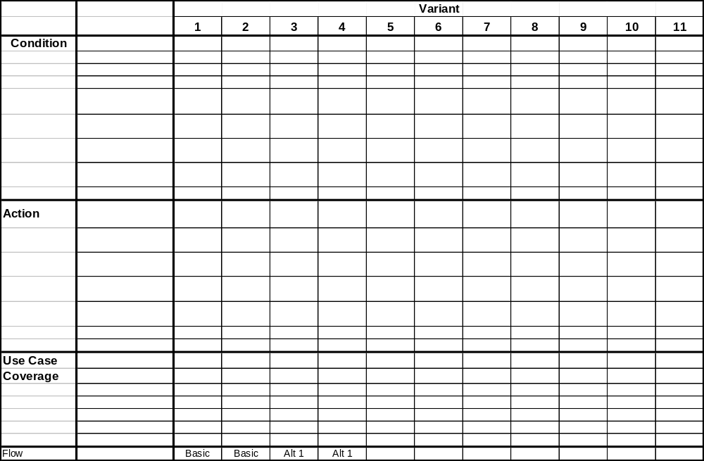

Issues
There are a number of implementation issues for this Use Case:
- The system provides the ability to bust trades, but much of the process described in this document is a business process that is not implemented or enforced by the system. Therefore, the Help Desk user is responsible for implementing a good portion of this Use Case.
- Due to a design limitation, the system performs asynchronous processing but does not provide asynchronous feedback to the Help Desk user. The following is an example of a typical trade bust scenario:
- The Admin GUI will submit a bust request to the server
- The server will perform some validation on the request and send a synchronous response to the Admin GUI that it has accepted the request.
- The server will process the request at some undetermined time in the future and the Admin GUI will not be notified of the success or failure of the bust request processing (i.e. the request could fail and the Help Desk user will not be notified)
The Help Desk user is responsible for monitoring the status of the trade bust request. This means that the Help Desk user must keep track of all original trade quantities and bust quantities and query the system through the Bust Trade screen to determine if the bust has been processed. If the trade bust has failed, it will be logged in the server logs. The traders will be notified if the bust is successful.
- The system does not know who the busting party is. This means that the Help Desk user will not be prevented from reinstating orders on both sides of a trade. Reinstating the order of the busting party is against the rules of this exchange. The Help Desk is responsible for enforcing this rule. Allowing the reinstatement of orders on both sides of a trade is a feature that allows the Help Desk user to restore the time priority of both parties’ orders. This feature can be used in the case of a system error (i.e. the system has filled the orders in error and neither party is at fault).

Design Comments

Pictures of the User Interface
<<include pictures of the user interface>>

GUI Flow of Events

Pictures of the User Interface

